**TITLE: Final Project v1.0**

**COURSE NAME: Introduction to Programming**

**COURSE CODE: <Redacted>**

**DATE: End of Week 15**

**By Matthew Rigo (s3840775) & Jack Sydenham (s3841816)**

**Table of Contents**

**Introduction………………………………………………………………………………….3**

**The Story……………………………………………………………………………………….3**

**The Objective………………………….…………..…………..……………………………3**

**Game Layout………………………….…………..…………..…………………………3-4**

**Locations………………………….…………..…………..……………………….…………5**

**Inventory/Interaction…………..……………………………………………………….6**

**Instructions………………….……………………………………………………………….6**

**ALGORITHMIC TECHNIQUES………………………………………………………….7**

**Pseudocode ……………………………..……………………………..………..…….7-14**

**INTRODUCTION**

The game is called “Drop-Fall”. Using your quick wit and strength you must take on the dangers of Sanity Island and retrieve the “Master Emerald” to save the world. This game uses numerical values to control the game, has 3 height levels, 11 physical locations and 8 interactable objects(items and npc’s). This game is designed to have a linear journey at the start with the opportunity for an alternate ending(death) until the player has reached “Sanity Island” where the player has more freedom to traverse between 9 locations freely.

**THE STORY**

You are a secret covert military operative on a mission to infiltrate Sanity Island to find the “Master Emerald”. You fly into the game on a plane and are forced to parachute down towards the island, once you have arrived there is a bunch of problems you (the player) must face as you traverse Sanity island including finding items, interacting with npcs and defeating the “Aggressive Echidna” to get the “Master Emerald” and give it to the military so they can power a laser weapon to stop a meteor from crashing into the earth.

**THE OBJECTIVE**

*Main objectives must be completed to ensure success

*Side objectives do not have to be completed but can help complete game

* Main Objective: Defeat the “Aggressive Echidna” and retrieve the “Master Emerald”
* Main Objective: Find Titanium for the blacksmith for him to craft you a weapon
* Side Objective: Find the Apple in the forest
* Side Objective: Visit the Bar to obtain a drink

**GAME LAYOUT**

In “Dropfall” there is 3 height levels. We start from a location 3000m above ground, then we have a second location 2999m-1m above ground, then we have the main game area on ground level, where the player can move back and forth between locations. (Player can not go back a height level during the game)

First level (3000m above ground): Helicopter location

Second level (2999-1m above ground): Parachuting location

Third level (ground level and also main level): Sanity Island, Sanity beach, helicopter_2, plane wreckage, East(forest), town, blacksmith shop, bar and North(Aggressive Echidna Battle) locations

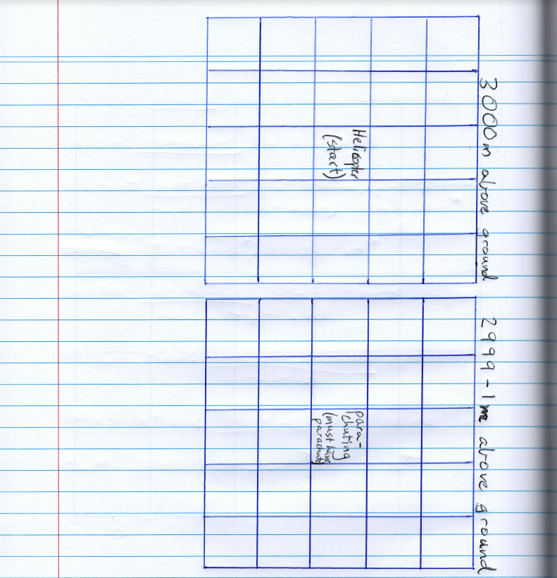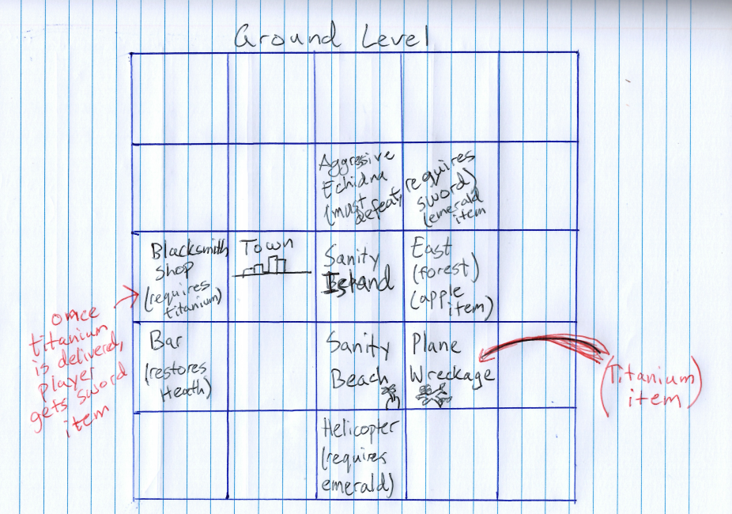

**LOCATIONS:**

|  |  |  |  |  |
| --- | --- | --- | --- | --- |
| Location: | Required items? | Items obtained from Location | Location Objective | Alternate ending? |
| Helicopter (3000m above ground) | No | Parachute | N/A | None |
| Parachuting (2999-1m above ground) | Yes, Parachute | None | N/A | Yes, death (if parachute is not pulled after 3 choices) |
| Sanity Island (Ground level) | No | None | N/A | None |
| Sanity Beach (Ground level) | No | None | N/A | None |
| Plane wreckage (Ground level) | No | Titanium | Scavenge Titanium from plane wreck | None |
| Helicopter (Ground level) | Yes, Master Emerald | None | Give Morpheus (NPC) the Master Emerald | Yes, End of game (main objective fulfilled) |
| East (Forest) (Ground level) | No | Apple | N/A | N/A |
| Town | No | None | N/A | N/A |
| Blacksmith Shop | Yes, Titanium | Sword | Give blacksmith titanium for sword | N/A |
| Bar | No | Health increase | N/A | N/A |
| North (Aggressive Echidna Battle) | Yes, Sword | Master Emerald | Defeat the “Aggressive Echidna” | Yes, death (if health of player is ‘0’ or less (from taking damage from “Aggressive Echidna”)) |

**INVENTORY/INTERACTION**

During the game you(the player) will interact with many npcs and items.

Items collected by the player will be stored in the “playerInventory” arraylist and be called upon when required.

The total items and interactions in “Dropfall” are (8):

1. Knife (item)
2. Sword (item)
3. Apple (item)
4. Titanium (item)
5. Parachute (item)
6. Morpheus (npc)
7. Blacksmith (npc)
8. “Aggressive Echidna” (npc)

**INSTRUCTIONS**

Run “MATTANDJACKGAME.java” on “Apache NetBeans IDE 12.0”

Game is controlled by user input via numerical values. For example, the game will ask the player if “they would like to start”. Number “1” might be yes and number “2” might be no. Please enter only integers for choices and string for player’s name. (After player’s name is entered at the start of the game the only required input would be numerical values from that point onwards)

(See example.1 on next page)

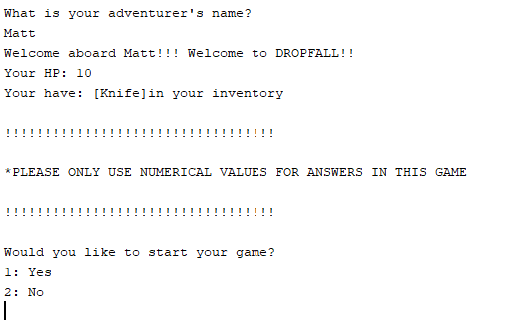

(Answer either “1” or “2”)

**ALGORITHMIC TECHNIQUES**

Arraylist (for inventory)

* An arraylist is used to store any items the player may obtain while playing the game. We chose an arraylist as it can be expanded upon as much as it is needed to (this is desirable in our game as there is many items to collect but not every item NEEDS to be collected, therefore the array will change in amount of indexes every game making an arraylist perfect for inventory)

Counter(for parachuting location)

* The “fallingCounter” counter is perfect to increment every time the player has made wrong choice to tell the game if the counter reaches a certain number (3), the game will execute an alternate ending (death). This is because in this level the player is falling through the sky towards the ground and they must make the right choices to survive in time hence making the counter count mistakes with enough mistake of course leading to the player’s death

Scanner (for user input)

* As this is a user driven game. The game requires the user inputs an action after every process in the game. This makes it so the user has free (to an extent) control over the game and what actions/paths they take

“If” statements (Most locations)

* If statements are used for pretty much every location as every location gives you a choice in the game and requires the player to input a numerical value for the shown choices.
* If statements are also used to check if certain items are in the player’s inventory. This is so they can continue their quest because without certain items the player will fail

**Matt and Jack Game Pseudocode Summary**

On start

‘newGame()’

Add “knife” to player inventory

Set variable “falling counter” to 0

Set “playerHealth” to 10

Set “monsterHP” to 15

Ask user for his/her name and save the inputted value for later

Display welcome message “Welcome to DROPFALL”

Inform the Player of what is in their inventory (currently only “Knife”)

Ask player if they want to start the game

Options: 1. Yes

2. No

IF 1

End the game

IF 2

Run ‘helicopter()’

Display text “You are a covert military operative on a mission. You are 5000m above the ground in a helicopter. Your leader Morpheus is waiting to brief you while he eats red jellybeans”

Ask player “What would you like to do?"

Options: 1. Ask Morpheus for the mission brief

2. Ask Morpheus for a jellybean

IF 2

Display text "Morpheus: HEY! These are mine!"

Run helicopter()

IF 1

Run ‘missionBrief()’

Add “Parachute” to inventory

Display text “Morpheus: Thanks for joining me on this mission (inputted player name). This mission is to Sanity Island to infiltrate and steal the Master Emerald. You will be parachuting into the island and I will be waiting at Sanity Beach once you have received the Emerald.”

Inform player that parachute has been added to their inventory

Display text “Are you ready? (player name)?”

Options 1. Yes. Let’s go

2. Can I wait a few minutes?

3. I’m Scared

4. Can I hear the mission briefing again

IF 3

Display text “don’t be a wimp, the fate of the world depends on you!”

Run ‘missionBrief()’

IF 4

Display text “Sure”

Run ‘missionBrief()’

IF 1

Display text “That’s the spirit”

Run ‘parachuting()’

IF 2

Display text “No, you have to go now”

Display text “Morpheus pushes you out of the helicopter”

Run ‘parachuting()’

Display text “You are freefalling in the air towards sanity island"

Ask player “What do you do?”

Options 1. Keep Falling

2. Pull Parachute

3. Look at the island

IF 1

IF ‘fallingCounter’ <3

Display text “You are accelerating towards the ground"

Add 1 to falling counter

Run ‘parachuting()’

Else IF

dead()

IF 3

IF ‘fallingCounter’ <3

Display text "The island is really beautiful but you are accelerating towards the ground"

Add 1 to falling counter

Run ‘parachuting()’

Else If

dead()

IF 2

Run ‘sanityIsland()’

Display text “You are at the center of Sanity Island. If you go south you go back to Sanity Beach"

IF “Master emerald is in the player inventory

Give option 3. Sanity beach

ELSE

Give player options 1. Go North

2. Go East

3. Go South

4. Go West

IF “Apple” is in the player inventory

Give option 5. Eat Apple

IF 1

‘north()’

Display text “You encounter an Aggressive Echidna!"

Show ‘monsterHP’

Show ‘playerHealth’

give options 1. Fight

2. Run

IF 1

IF player has “sword in inventory”

Display text “you are ready to battle”

Run ‘battle()’

Else

Display text “your weapon is too weak”

Run north()

IF 2

Run ‘sanityIsland()’

IF 2

‘east()’

Display text "You walked into a forest and found an Apple"

Add “Apple to ‘playerInventory’

Inform the player that “Apple” has been added to their inventory

Give option 1. Go back to Sanity Island

IF 1

Run ‘sanityIsland()’

Else

Run ‘east()’

IF 3

‘sanityBeach()’

Display text "Morpheus is waiting in the helicopter on the beach"

Give options 1. Talk to him

2. Look around

3. Go back

4. Steal helicopter

If 1

IF player’s inventory contains “Master Emerald”

Run ‘ending()’

Else IF

Morpheus asks player to come back when they have the emerald.

IF 3

Run ‘sanityIsland()’

IF 4

Display text “Hey, stop trying to be a funny guy (player name).”

IF 2

Display text "You notice a plane wreckage on the other side of the beach"

Run ‘planeWreckage()’

Display text "The plane wreck looks quite old. The plane's shell is made of titanium.

Inform the player that they have scavenged the titanium and it has been added to their inventory.

Add the titanium to the playerInventory

Give option 1. Go back

IF 1

‘sanityBeach()’

Else IF

‘planeWreckage()’

IF 4

‘town()’

Display text "You walk into the town. There is a town and a bar”

Give options 1. Go to the blacksmith

2. Go to the bar

3. Go back

IF 1

Run ‘blacksmithShop()’

Display text “There is a blacksmith”

Give options 1. Talk to the blacksmith

2. Attack the blacksmith

3. Go back

IF 1

IF player has “titanium” in inventory

Display text "Thank you (player name) I can craft many weapons with these"

Add “sword” to inventory Run

Else

Blacksmith tells player to bring titanium to him if they want him to make a sword

IF 2

Display text “Blacksmith: Hey! Get away from me”

Lower playerHealth by 1

Display playerHealth

IF 3

Run ‘town()’

IF 2

Run ‘bar()’

Display text "You relax at the bar and have a drink"

Add 1 to playerHealth

Show playerHealth

Give option 1. Go back

IF 1

Run ‘town()’

IF 3

Run ‘sanityIsland()’

IF 5

Display text “you received HP!”

Add 3 to current player health

Display ‘playerHealth’

Remove “Apple” from player inventory

**Battling the Aggressive Echidna**

‘battle()’

If the fight option is selected north of ‘sanityIsland’, this method runs

The sword allows for damage to be done to the monster, however the amount of damage done is a random value between 0 and 8.

Every time the ‘fight’ option is selected, both the player and the monster attack each other, with the monster dealing between 0 and 4 damage

After every attack the damage done to both the player and monster are shown

IF playerHealth reaches 0 or less, Run ‘Dead()’

Display text “You are dead"

Display text “-GAME OVER-“

If the monster is defeated before the player runs out of health, the player will be rewarded with “Master Emerald”, with text to inform them that they have received it.

The player is then left with a single option 1. Go back to Sanity Island

If the player returns to Morpheus and talks to him, they will have reached the end.

‘ending()’

Display text “Morpheus: Congratulations You can go home! Thank you for your service"

Display text “THE END”

Run ‘quitGame()’

Display text “Game quit, Would you like to start again?”

Give options 1. Yes

2. No

IF 1

Run ‘newGame()’

IF 2

Close program

END